SSW-420/600 Series

Microcomputer Electric Heating Constant Temperature
Water Bath

Instruction Manual

SHANGHAI BOXUN INDUSTRY & COMMERCE CO.,LTD. MEDICAL EQUIPMENT FACTORY
Ⅰ Sketch map
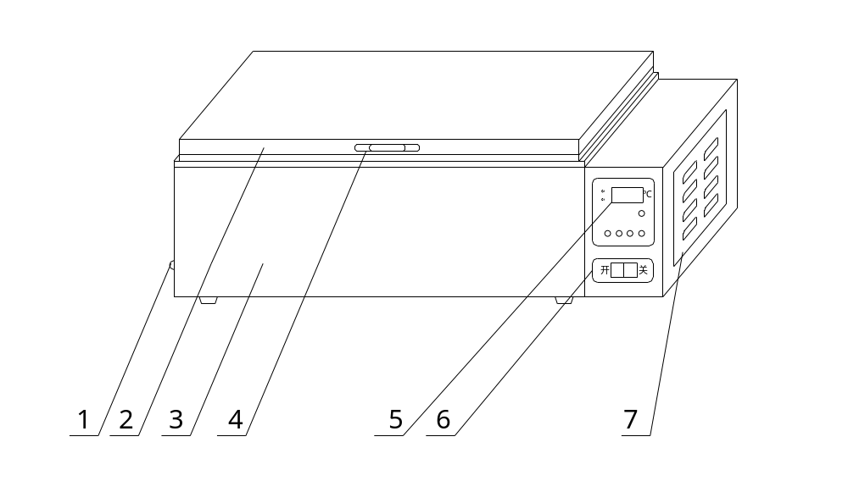
1. drain plug 2. cover 3.outer 4.cover handle
5. control panel 6. power switch 7. temperature control device side plate
Ⅱ Scope of application
It is used for precise constant temperature and assistant heating in medical sanitation, industry and mining enterprises, scientific research institute and medical college for inspecting and testing pathology blood serum.
Ⅲ Main technical parameters
Model | SSW－420-2S | SSW－600-2S
Power supply | 220V 50Hz
Power consumption | 500W | 800W
Temp. range | RT+5－100℃
Temp. fluctuation | ±0.2℃
Temp. Alarm | 2±0.5℃
Working Dimensions | 420×190×150(mm) | 600×300×180(mm)
Working ambinet | Temp.10℃－30℃ Humidity≤75%RH
Ⅳ Strcuture
The outer of electric heating constant temperature water bath is made of high quality cold-rolled steel plate and coated with plastic. The chamber and cover and shelves are made of stainless steel plate. The U-shape heater is placed on the bottom. Temperature control adopts microcomputer temperature controller.
Ⅴ Use method
1. Add clean water into bath to 1/2~2/3 of total height.
2. Place the power switch to “ON”, it indicates power connected when temperature control panel displays number.
3. Open the power switch, power indicate light is on, and system begins work.
4. Alarm light is on when it over temperature for 2℃, and system stops heating automatically.
5. Setting method:
(1) Press the Set key, and it displays to set the temperature value(℃).
X
S

X5
X5

(2) Press the Set key again, and it displays , it returns to tempearture display after 2 sec, and finish the setting.
X
G
O
X5
X5
D
(3) Work key: press the Work key and working light is on, system begins heat and temperature control.
(4) Left move key: press it to move cursor left.
(5) Increase/decrease key: increase/decrease the value which is set.
Ⅵ Notes of panel

Ⅶ Notes of connection
temperature component
display panel

power supply

heater

Ⅷ Maintenance
1. Keep the water bath clean. Avoid to clean it with corrosive chemical solutions and then chemical reaction happens.
2. If you don’t use the equipment long-term, you should put it into training room with plastic film coverer to avoid wetting.
3. Don’t use the equipment in the environment with high-voltage, high current, high magnetic field or corrosive gas to avoid the equipment damage occurred and the risk of electric shock。
Ⅸ Notice
1. The water bath should have reliable grounding to ensure the safe use.
2. Don’t press the power switch before add water to prevent burning the heater.
3. If it is unnecessary, please don’t open the temperature control device for safety.

